CHINA’S PUBLIC DIPLOMACY ON TWITTER AND FACEBOOK

A Data Exploratory Study

EXECUTIVE SUMMARY

**Total**

Overall, the project studied China’s diplomatic activity from October 14, 2019 to December 8, 2020. Over this time period, a total of 432,800 messages were collected from 372 Chinese diplomatic accounts on Facebook and Twitter.

**An Average Week of Chinese Public Diplomacy**

Across an average week in 2020:

* On average there are 227 active users across Facebook and Twitter each week.
  + 156 active users on Twitter each week
  + 72 active users on Facebook each week
* They’ll post 8,057 times in total. 6,993 times on Twitter and 1,063 on Facebook;
* On Twitter, these messages will together receive 312,151 Retweets per week, about 44 per message.

**Do they find an audience?**

Digital spaces are often noisy ones, where messages can go largely unseen or unheeded. This is not however the case for China’s public diplomatic presences, who in general find an audience and provoke a reaction.

* On Facebook, they had on average 456,570 subscribers per account.
* On Twitter, they had an average of 255,002 followers
* On Facebook the total number of interactions can be summarized in Tab.1

|  |  |  |
| --- | --- | --- |
| Metric | Average per message | Average per week |
| angryCount | 1.34 | 1426 |
| careCount | 0.87 | 203 |
| commentCount | 15.3 | 16352 |
| hahaCount | 2.06 | 2197 |
| likeCount | 169.8 | 180642 |
| loveCount | 14.2 | 15108 |
| sadCount | 2.5 | 2671 |
| shareCount | 23.4 | 24938 |
| Average number of engagements | 231 | 245,102 |

Tab.1. Summary of Facebook engagement metrics

**An Increase in activity**

Since 2019, the number of messages sent by these nominated accounts has significantly increased. From mid-October 2019, the rate roughly double each week, up till week 51 where the rate stabilised at around 11,000, albeit with some sharp fluctuations.

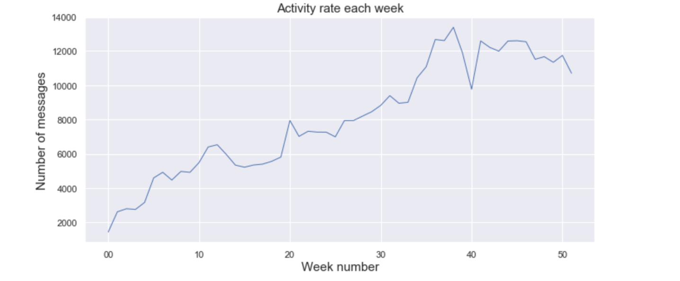  
Fig.1. Messages per week (2020)

This increase occurred:

* Mainly in the English language.
* Mainly on Twitter
* Mainly due to state media outlets
* And mainly due to accounts based in the Asia Pacific region.

There are also important caveats to this increase, discussed later in the report.

**China’s Messengers**

The project collected the activity from:

* + 36 Chinese Ambassadors
  + 131 Confucius Institutes
  + 15 Consulates General
  + 129 Embassies
  + 63 Media outlets
  + 7 Ministry officials
  + 3 Other diplomats

State media outlets are by far the most prolific senders of messages, but Ambassadors, embassies and Ministry officials are the most amplified by other social media users.

**China’s Message**

In terms of overall proportions, the same overall themes remained consistently important across region, account type, and largely by language too. ‘Geopolitics’ was by some margin the theme most likely to be raised by these accounts, followed by ‘politics and society’ and ‘COVID-19’.

Over time, there was also a common shape across many regions and languages. Geo-politics remained generally preponderant as the theme of emphasis, but each saw a sharp spike in COVID-19 messaging around March 2019, with the level then slowly declining in the months thereafter.

**China’s Focus**

Overall, the main language of focus, by far, was English. It consisted 58.94% of the total dataset, followed by Arabic (10.78%), Spanish (7.96%) and French (4.6%).

The project analysed more accounts from Europe (104) and the Americas (101) than any other region. This was allowed by the Asia Pacific.

However, far more messages were sent by accounts based in the Asia Pacific (297,053) than either Europe (41,573), the Americas (47,193) or any other region studied.

**Performance of the analytics**

Keyword annotators were used to identify themes. A total of 4 were built across French, English, Arabic and Spanish. They together composed of 1593 keywords, and performed with an average F1 score (see below) of 0.507.

Part 1. Methodology

INTRODUCTION

This project is dedicated to understanding the public diplomatic activity of China on Twitter and Facebook. It has sought to understand how China uses these social media platforms, the kinds of messages that its diplomatic actors publicly propagate, the audiences that they might be addressing and the languages that they may be addressing them in.

Primarily, the project has been data exploratory in nature, seeking to measure the overall scale and nature of this activity, the main themes that the messages fall into, and broad patterns over time and across language that can be discovered. Second, it attempts to provide information that will allow the reader to make an informed determination about the overall benefits and challenges of this kind of analysis. Third, the report discusses the techniques that have been used to perform the analysis itself, their measurable performance, and the implications of these methods for the results and how they should be understood.

APPROACH

The project was divided into six phases.

**Stage 1. Data Collection**

The project began with a series of steps to develop an architecture to collect Chinese public diplomatic activity on Twitter and Facebook.

* First, a ‘Master List’ of accounts was developed in collaboration with BBCM. These were accounts that were understood by BBCM to each represent a Chinese public diplomatic presence online, to consolidate these accounts into a single list and, combining both automated and manual means, to include information about each account covering:
  + Its region;
  + Its country;
  + ‘Account type’ - the kind of public diplomatic presence that it represents;
  + The language/s that it is active in;
  + When it was created.
* Using Method52 (see below), CASM undertook data collections for these accounts. For Facebook accounts, the CrowdTangle dashboard was used. For Twitter accounts, data was collected from Twitter’s ‘Steam’ Application Programming Interface. 381 accounts were included in the Master List from BBCM, and 370 were collectible using these methods.
* The Master List was thereafter used as a single point of truth between CASM and BBCM to define the project’s data collection. It was updated once on 17 November 2020 to reflect changes in appointments to China’s diplomatic staff.

*A quick note about the Master List and the data presented in this report.*

The Master List was an extremely important source for two of the analytical observations that this report makes:

* *‘*Account Types’: Each account was placed into one of 7 account categories by BBCM. These formed the basis for any comparison made in the report, below, between the behaviour of each of these different kinds of Chinese public diplomatic presence online.
* *‘*Outlet Types’: Each account was also placed into one of 4 outlet types provided by BBCM. These helped distinguish the messaging tool used by Chinese public diplomacy, whether it is media, diplomatic, educational (CI) and central (official central).
* Regions: the report also draws regional distinctions between China’s public diplomatic presences. This is again based on the Master List, where each account was manually placed into a specific region, based on where the actor is based. It should be noted that this does not necessarily imply that there is a perfect overlap between the region where the actor is based and the region of the intended audience that actor was attempting to reach.

*Timeframe:*

The time window selected for the project (October 2019 to December 2020) was chosen to meet the data collection opportunities available to the project team. Whilst Twitter data was collected that stretched back till 2009, Facebook data could only be consistently acquired from October 2019, and so this was selected as the starting point to avoid artefacts in the data created by data collection limitations. The end date - December 8th, 2020 - was the day where we started our interaction with the data in terms of thematic classification.

**Stage 2. Identifying Languages and Formation of Language teams**

An initial dataset was collected according to the process set out in Stage 1, above. This was passed through a language extraction algorithm within Method52 (see below), which organised each message into the category of language that it was most likely to be.

These language breakdowns were presented to BBCM stakeholders, and the four most prevalent languages were selected to be analysed: English, French, Arabic and Spanish. BBCM convened teams for each of these languages comprising of fluent speakers in them, with each tasked to collaborate with CASM technologists to complete the analytical steps laid out in Stage 3.

**Stage 3. Identifying Themes**

The next stage was to undertake a process to identify the themes that the project would seek to identify. The process to do this was inspired by a well-known sociological method called ‘Grounded Theory’. This process emphasises the importance of analysing data using categories that are iteratively and constantly drawn from the data itself by analysts working face-to-face with it. In general, this tends to reconcile the researcher’s idea of what comprises a category with the actual data itself, creating an eventual framework which reflects both.

To begin this process, an initial series of themes was shared by BBCM. Sessions were then held with each of the language teams to appraise 1,000 randomly selected messages and attempt to categorise them. As new messages were seen, they were either placed into an existing category, or caused a new category to be created.

This process lasted for roughly a month, and created an updated themes list. These were then centralised, and presented to BBCM, and a final thematic framework was created that reconciled the individual products of each of the language teams. Eventually, eight themes were identified:

* ‘Economy’;
* ‘Politics and Society’;
* ‘COVID-19’;
* ‘Technology’;
* ‘Environment’;
* ‘Military and Society’;
* ‘Geopolitics’;
* ‘Chinese culture and people’;

A full list of the many sub-themes that these overarching themes contained is included as an annex to this report.

**Stage 4. Building the Keyword Thematic Annotators**

The project next moved to building keyword annotators to categorise messages into the themes identified in Stage 3. Keyword annotators are analytical components within Method52 that place any message into a category if they contain a given word. To do this, the same process was conducted with each of the language teams:

* 1000 randomly selected messages were sent to each language team, and marked into each of the themes (or indeed none of them) that were identified during Stage 3.
* CASM used a statistical language analytical count called TF-IDF to identify keywords that most correlated with messages marked into each of these themes.
* These candidate keywords were presented by CASM to each of the language teams. The keywords were appraised and either added as keywords or discarded,
* Additional messages were then placed into any of these categories if they contained a keyword identified through the process above.
* These were apprised by the country teams, and keywords were both added and removed. This iteratively created a series of additional versions of the keyword lists.
* The performance of each version was measured (see below) and the keyword lists with the highest performance were used to produce the final analysis.

**Stage 5. Testing the Keyword Thematic Annotators**

The measurement of the performance of each of the keyword annotators, for each of the languages, was an important part of the project. In order to do this an evaluation dataset was created for each language. The language teams were given an additional set of 30 messages which they manually categorised into themes. The automated and human categorisations were compared, with the automated result being correct if it agreed with the human categorisation.

This measurement of the keyword annotators produced three important metrics:

* *Recall*: The number of correct selections that the annotator made as a proportion of the total correct selections it could have made.
* *Precision*: The number of correct selections the annotator made as a proportion of all the selections it has made.
* *Overall, or ‘F1’*: All annotators are a trade-off between recall and precision. Classifiers with a high recall score tend to be less precise, and vice versa. ‘F1’ equally reconciles precision and recall to create one, overall measurement of performance for the annotator.

Across each language, this process was conducted several times, where the keyword list was refined, its performance measured against a new set of messages, and then the results considered by the team. The keyword lists with the highest overall performance were then finally used to conduct the analysis.

The overall performance of all annotators across all themes and languages was 0.507 f1_score. The breakdown of these results is shown in the following table (see Tab.2):

|  |  |  |  |
| --- | --- | --- | --- |
| Language | F1-score | Precision-score | Recall-score |
| Arabic | 0.519 | 0.626 | 0.482 |
| English | 0.566 | 0.627 | 0.545 |
| Spanish | 0.47 | 0.616 | 0.425 |
| French | 0.476 | 0.434 | 0.573 |

Tab.2. Keyword annotator performance per language

**Stage 6. Reporting and Visualisation**

Finally, the final keyword lists were used to categorise all of the messages that were collected. The results were exported into a third-party data visualisation package, and visualised for this report.

**Research Ethics**

Issues of privacy online are complex. In some cases, online spaces are clearly public - such as Twitter’s timeline - or clearly private - such as direct messages on Facebook. In some cases, the privacy of some spaces is more ambiguous, such as very large fora where membership is required. In addition to this, public perceptions of what social media spaces are public and which are private can vary significantly from the legal reality or terms of service. Because these discrepancies between reality and perception relate to issues of autonomy, the acquisition and recording of data must be well considered, justified and documented.

Given that the phenomenon studied in this report is public diplomacy, we assess that the individuals or teams producing the information studied have very little reasonable expectation of privacy. They are official public diplomacy accounts who by their very nature produce messages that are entirely public and indeed intended to be read by a wide audience.

Information was only collected from public Twitter and Facebook, and inline with the data availability rules that those platforms stipulate. No activity undertaken by any individual or institution that is not a verified Chinese diplomatic presence was collected for this project or is presented in this report.

**Technology - Method52**

The core technology used in this project was a platform developed by CASM Technology called Method52. It has been built to allow people from outside of formal data science backgrounds to collect, analyse and visualise datasets that are very large and unstructured. This is especially the case for large, text-based datasets, such as those drawn from social media, but has also included datasets comprised of emails, forum data, and internal and proprietary data held by large organisations.

The design principle of Method52 is to create a development environment through a graphical

user interface (GUI). Users select, configure and connect a number of components to create a

bespoke pipeline that data flows through. Each of these pipelines is designed to perform a

particular task and often a number of pipelines are themselves connected together to fulfil a

particular research-driven function. There are 82 components in Method52, and many of these can themselves be configured to perform a number of different tasks. Fig.2 shows a screenshot that describes Method 52’s GUI.

pasted-image.tiff

Fig.2. Screenshot describing the GUI of Method 52

Part 2. Results

**Section 1. China’s Public Digital Diplomats**

The activity of 370 Chinese diplomatic accounts were collected for this report; 225 on Twitter and 145 on Facebook. From October 14, 2019 to December 8, 2020 (the active period of data collection for this project), they produced a total of 432,800 messages; roughly 365,000 Tweets and 67,800 Facebook posts.

Noting important caveats (outlined in the discussion section, below), China’s public diplomatic presence has likely been growing since at least the middle of 2019, according to the accounts identified by BBCM. First, the number of messages that these accounts have sent has increased consistently over this time period, doubling roughly every week for the first 50 weeks.

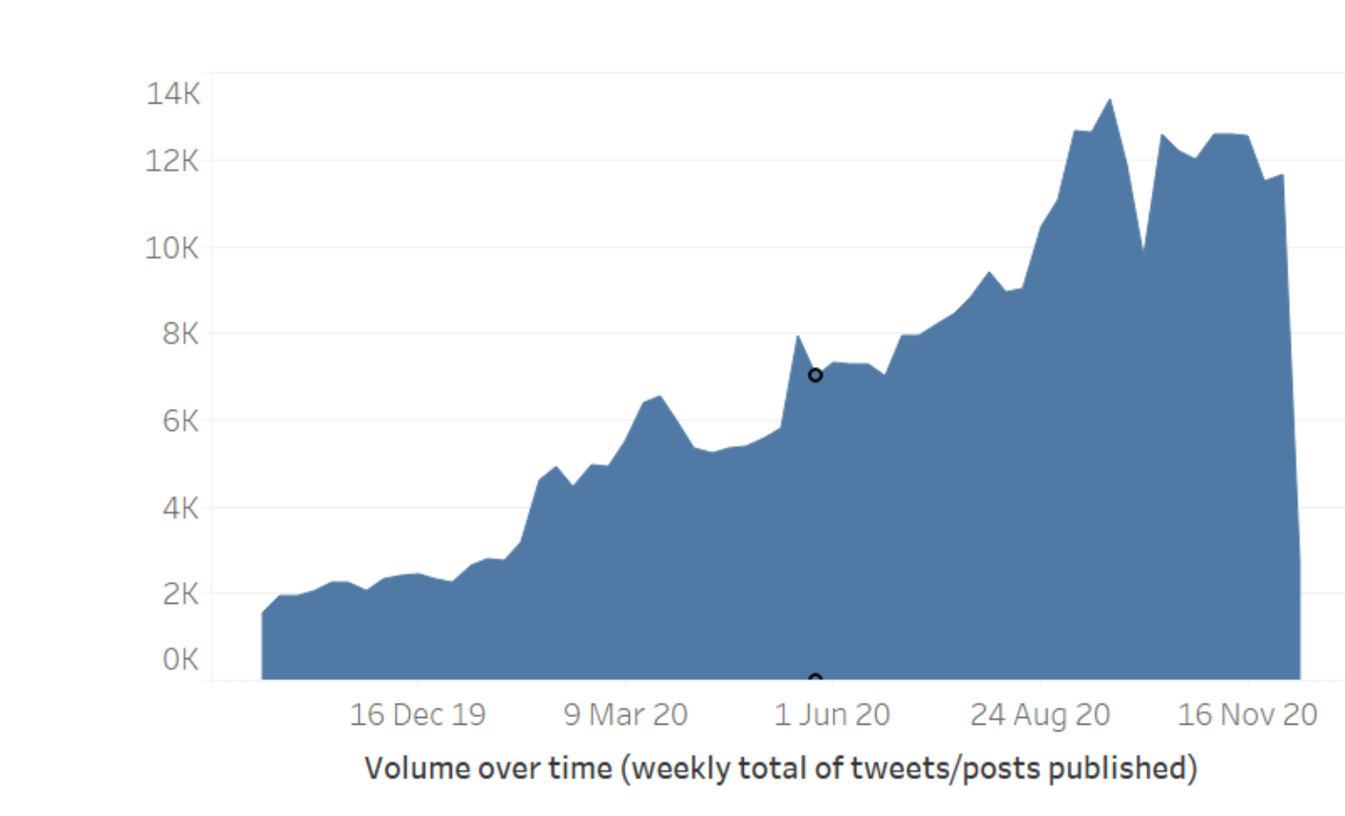

Fig.3. Total messages (posts/tweets) VOT (October 14, 2019 to December 8, 2020)

Both Facebook and Twitter saw an increase in the number of active accounts since October 2019 (see Fig.3), subject to important caveats set out in the discussion section of this report.

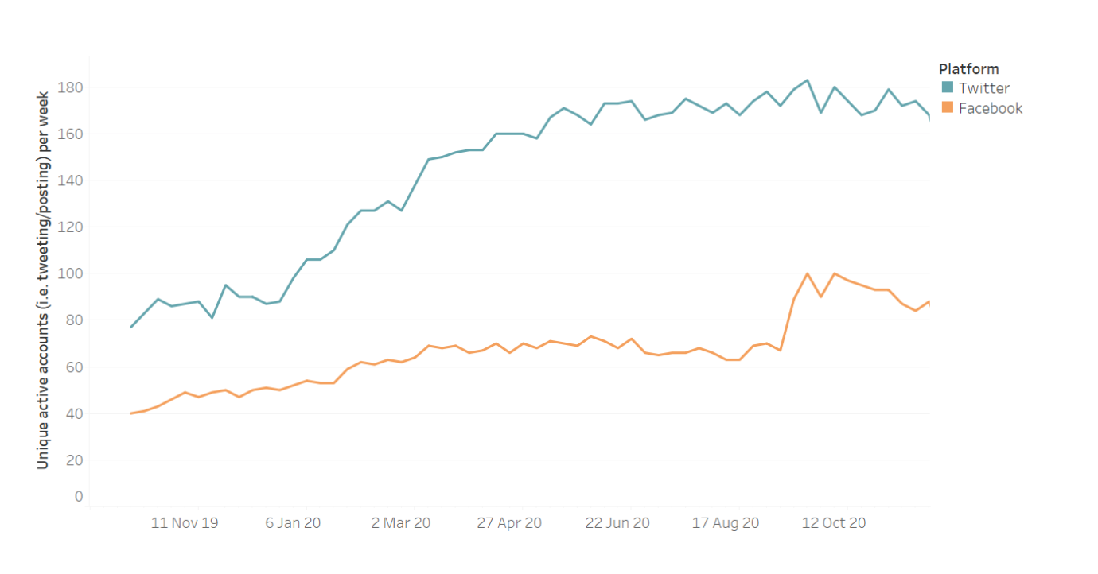

Fig.4. Shows the increase in the number of active accounts in Facebook and Twitter (October 14 (2019 to December 8, 2020)

The increase in the number of active Twitter accounts has been reasonably continuous since October 2019. The number of active Facebook accounts, however, followed a different profile. It stayed fairly stable from December 2019 until August 2020, but then saw a marked uptick from there till November of the same year before witnessing a slight decline (see Fig.4 and 5).

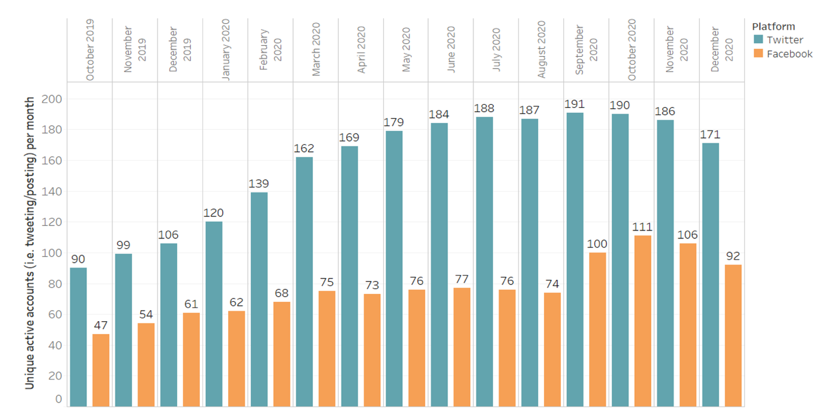

Fig.5. Shows the increase in the number of active accounts in Facebook and Twitter per month (October 14, 2019 to December 8, 2020)

However, it was largely an increase in messaging on Twitter that explains the increase in the volume of messages overall. The volume of messages sent on Facebook did increase, but at a

markedly lower rate throughout the period studied (see Fig.6).

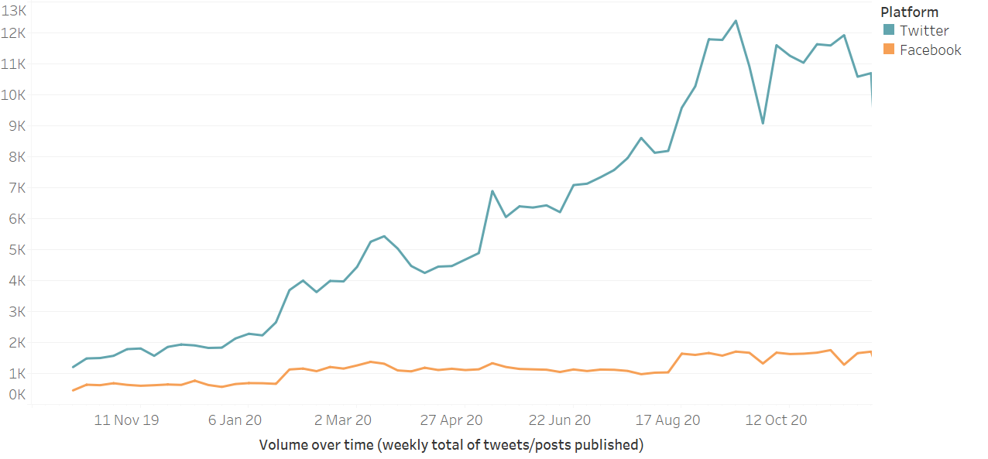

Fig.6. Shows the increase in the total number of messages over time (October 14, 2019 to December 8, 2020)

**Regions**

Every account in the Master List (see above) was manually placed into one of 7 global regions where that actor is based:

* 40 in Africa;
* 101 in the Americas;
* 102 in Asia Pacific;
* 13 in Eurasia;
* 104 in Europe;
* 5 International;
* 16 in Middle East

The total number of messages produce by all accounts in each region:

* 21588 messages sent from Africa;
* 47193 messages sent from Americas;
* 297053 messages sent from Asia Pacific;
* 1896 messages sent from Eurasia;
* 41573 messages sent from Europe;
* 6141 messages sent from International;
* 11565 messages sent from Middle East;

However, the activity of China’s diplomatic accounts based in a number of regions have not increased over this time period. This is the case in Africa, where the overall volume of messages produced by accounts in that region have stayed consistent over the period of study, with an increase from around January 2020 (see Fig.7).

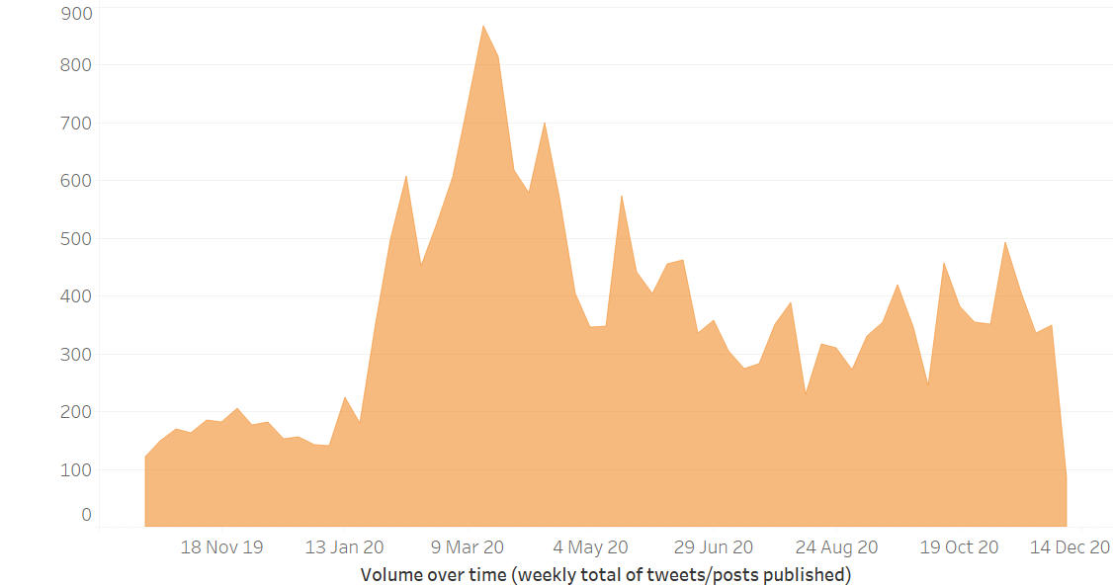

Fig.7. Shows the activity of China’s diplomatic accounts over time (Africa) (October 14, 2019 to December 8, 2020)

Accounts based in the Americas and Europe also saw increases in January 2020, but no substantial increase in the months thereafter (see Fig.8 and 9 respectively).

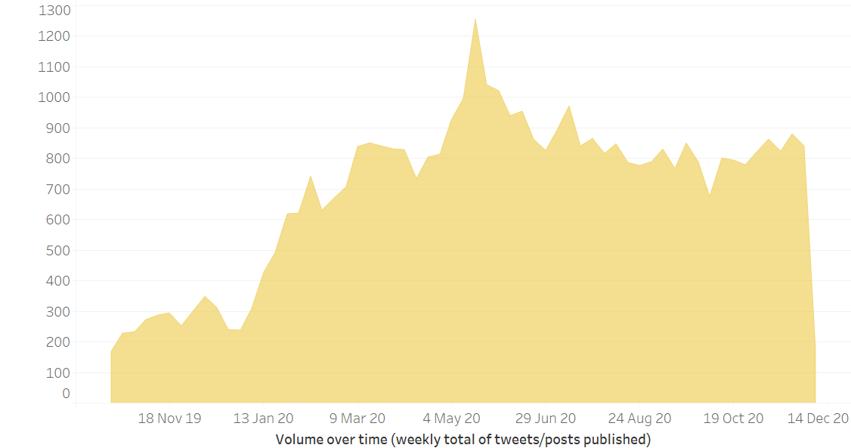

Fig.8. Shows the activity of China’s diplomatic accounts over time (Europe) (October 14, 2019 to December 8, 2020)

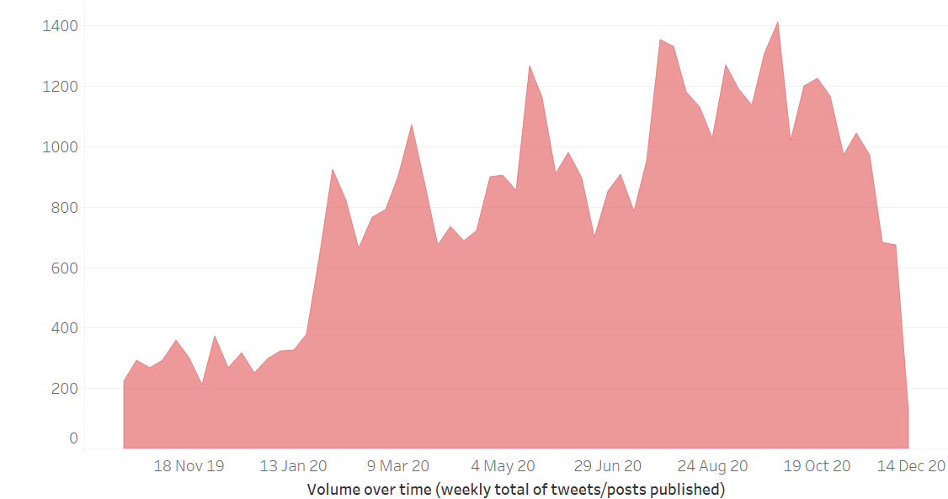

Fig.9. Shows the activity of China’s diplomatic accounts over time in (Americas) (October 14, 2019 to December 8, 2020)

It was accounts based in the Asia Pacific that constituted the most significant and sustained increase in the volume of messages over the period of study. Unlike the other regions, there was not a sharp increase around January 2020, but a gradual and continuous increase over the months that follow (see Fig.10).

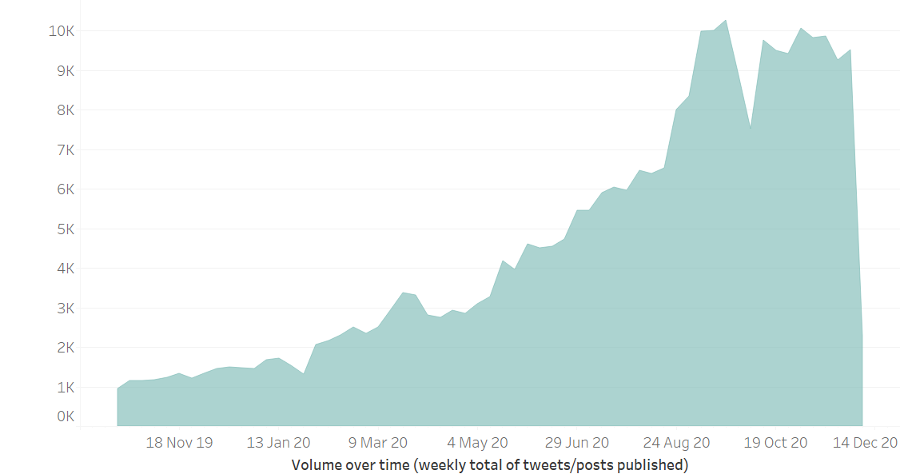

Fig.10. Shows the activity of China’s diplomatic accounts over time in (Asia Pacific) (October 14, 2019 to December 8, 2020)

When set side by side (and on the same scale), the significant of the increase in activity by accounts in the Asia Pacific becomes easier to see (see Fig.11).

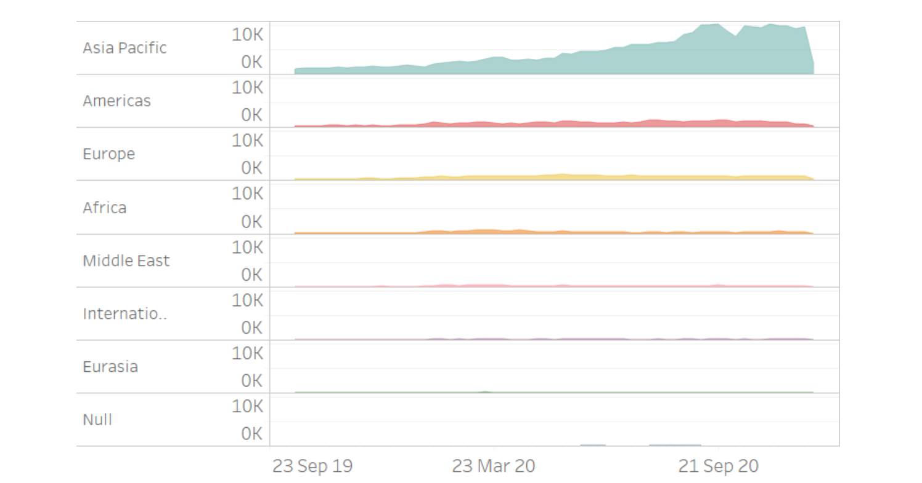

Fig.11. Shows the activity of China’s diplomatic accounts over time in (all regions) (October 14, 2019 to December 8, 2020)

**Section 2. China’s Public Diplomatic Messengers**

**Account Types** Each account was placed by BBCM into one of seven ifferent categories based on the kind of public diplomatic presence that it is. State media outlets were, by far, the most prolific kinds of accounts that the project collected from, followed by embassies and ambassadors (see Fig.12).

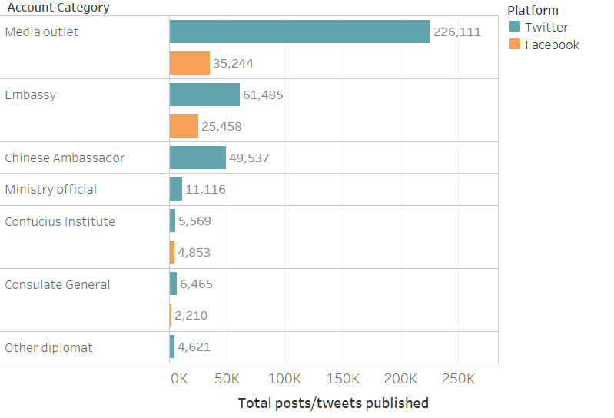

Fig.12. Shows the activity of China’s diplomatic accounts based on categories (October 14, 2019 to December 8, 2020)

The overall increase in Chinese public diplomatic activity (as discussed in the section above) was largely due to an increase in the volume of messages from state media outlets and, to a lesser 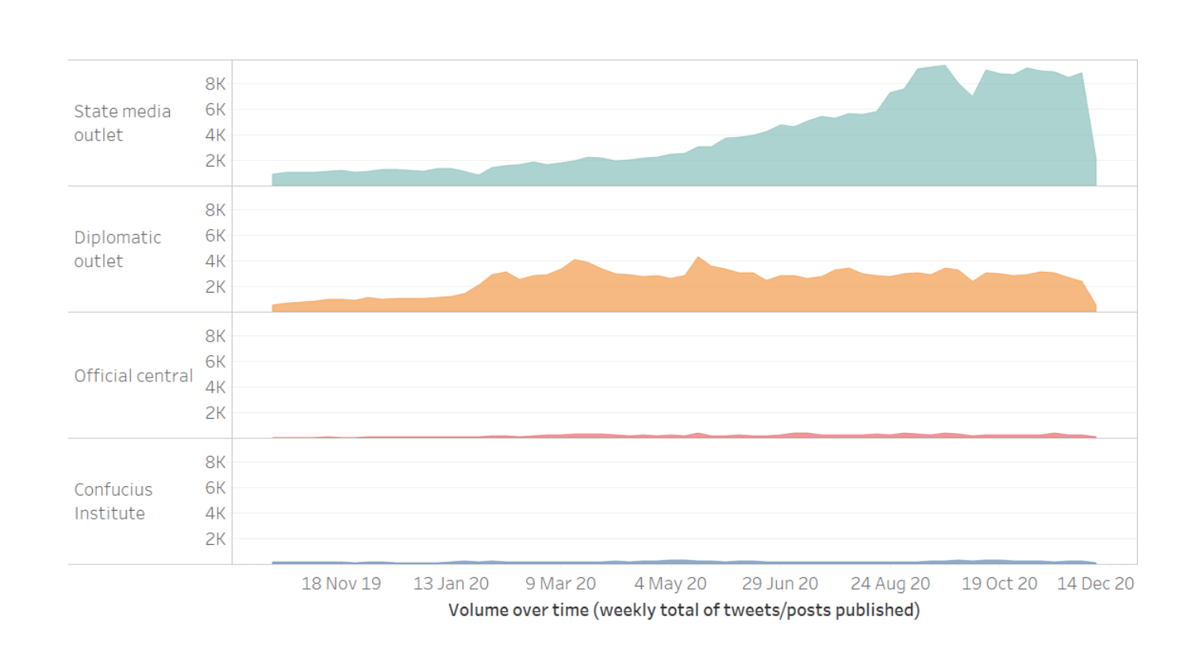degree, other diplomatic outlets (see Fig.13).

Fig.13. Shows the activity of China’s diplomatic accounts over time based on outlet type (October 14, 2019 to December 8, 2020)

The volume of output from media outlets saw two sharp increases. The first occurred on of 27 January 2020 and coincided with a similar increase in volume from embassy accounts. The second occurred in 17 August 2020 and did not coincide with an increase from any other types of account.

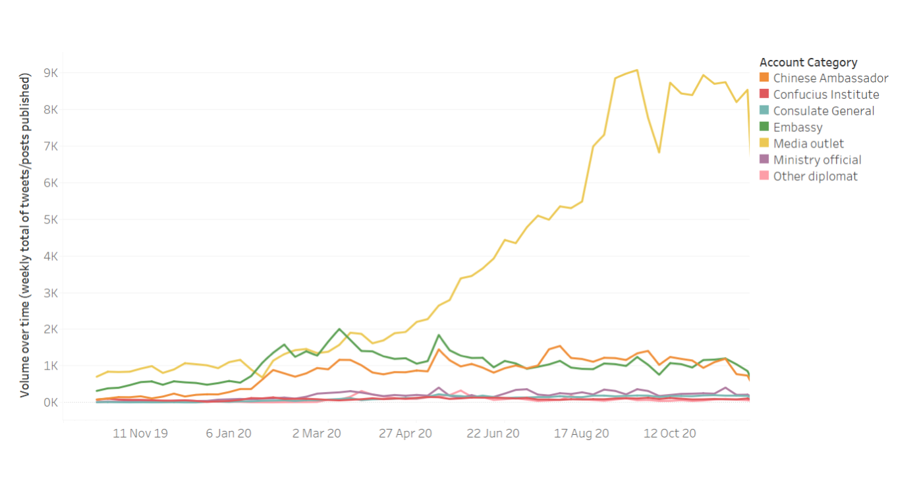

Fig.14. Shows the weekly activity of China’s diplomatic accounts over time based on account categories (October 14, 2019 to December 8, 2020)

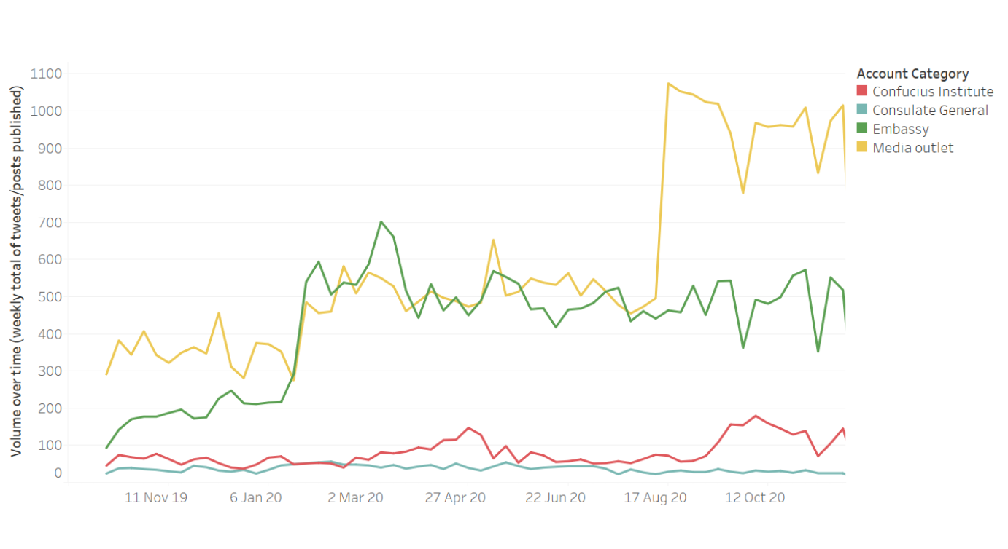

Fig.15. Shows the weekly activity of China’s diplomatic accounts over time based on 4 categories (October 14, 2019 to December 8, 2020)

**Prolific Accounts**

The most active state media accounts were substantially more prolific than any other type of account. However, whether state media outlets, ambassadors or embassies, the most prolific diplomatic voices were extremely prolific. Between October 14, 2019 to December 8, 2020, the 10 most active across these three categories sent an average of XXX messages, or YYYY a day. This is Z of the total amount collected.

Ahmed

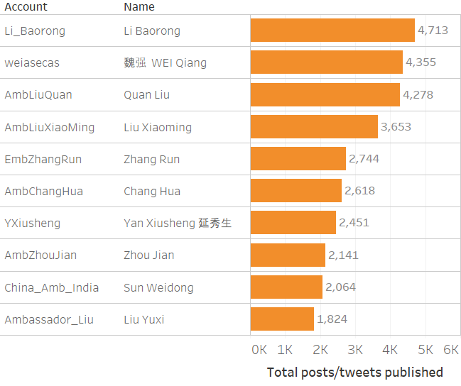

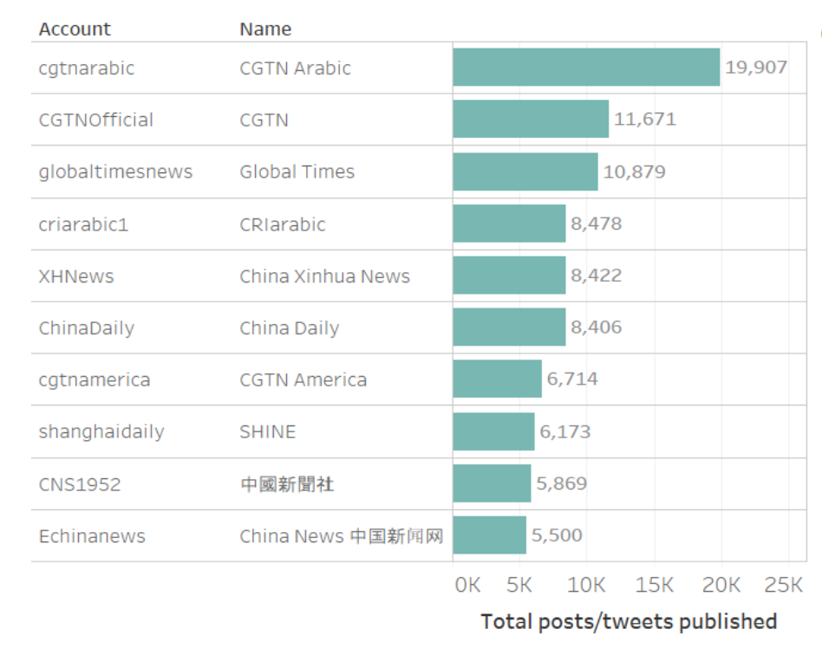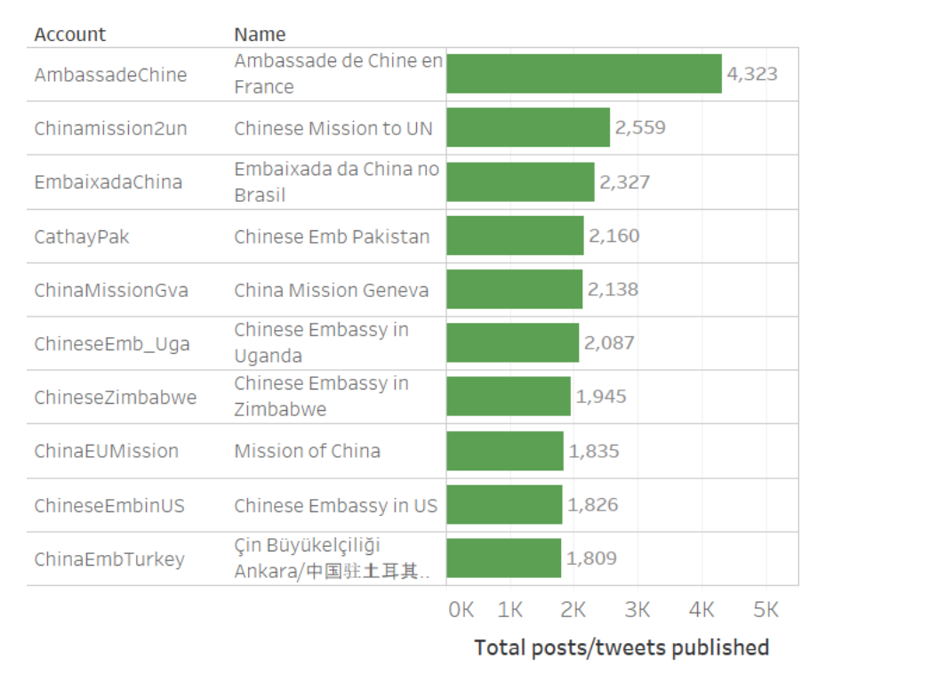

Fig.16. Shows the 10 most active accounts for Ambassadors (orange), State media outlet (light blue) and Embassies (green) (October 14, 2019 to December 8, 2020)

**Engagement**

Yet whilst state media have the most prolific accounts in terms of messages sent, they are not the accounts that are most engaged with. The three most engaged with accounts on Twitter are an ambassador, a Ministry official and an embassy.

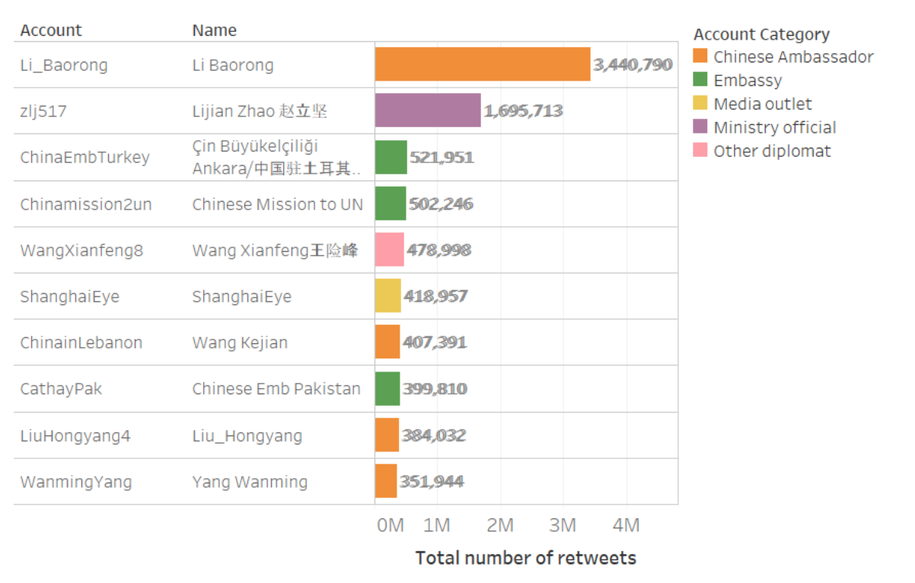

Fig.17. Shows the top10 retweeted accounts coloured by account category. (October 14, 2019 to December 8, 2020)

Summary of engagement, interaction and amplification metrics:

* + On Facebook, they had on average 456,570 subscribers per account.
  + On Twitter, they had an average of 255,002 followers
  + On Facebook the total number of interactions can be summarized in Tab.1
  + On Twitter, messages receive 312,151 Retweets per week, about 44 per message.
    - Fig.17. describes the total number of retweets each week. Notice that there were two peaks in week 11 and week 38 the rest of the week are roughly stable.

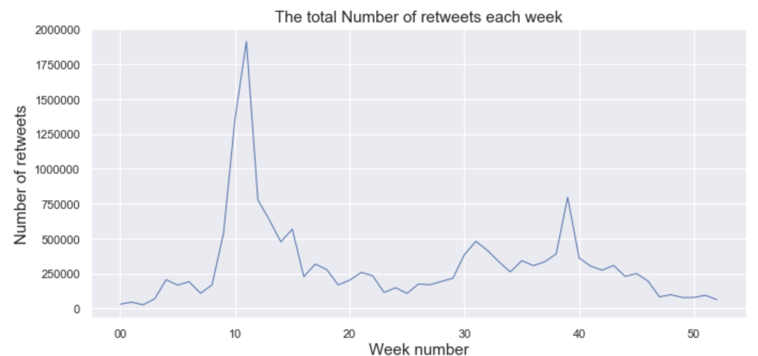

Fig.17. The average of the total number of retweets each week (2020)

**Section 3. China’s Public Diplomatic Message**

**Languages**

The account collected sent messages in 49 different languages during the duration of this project’s study. 58.94% of the overall languages were sent in English. The most prolific other languages were Arabic, Spanish, French which, together with English comprised the four target languages for this study (see Fig.18).

|  |  |
| --- | --- |
| **Code** | **Language** |
| **ar** | **Arabic** |
| **de** | **German** |
| **en** | **English** |
| **es** | **Spanish** |
| **fr** | **French** |
| **it** | **Italian** |
| **ja** | **Japanese** |
| **ta** | **Tamil** |
| **tl** | **Tagalog** |
| **zh-cn** | **Chinese Simplified** |
| **zh-tw** | **Chinese Traditional** |

Tab.3. Description of the language code used in Fig.18.

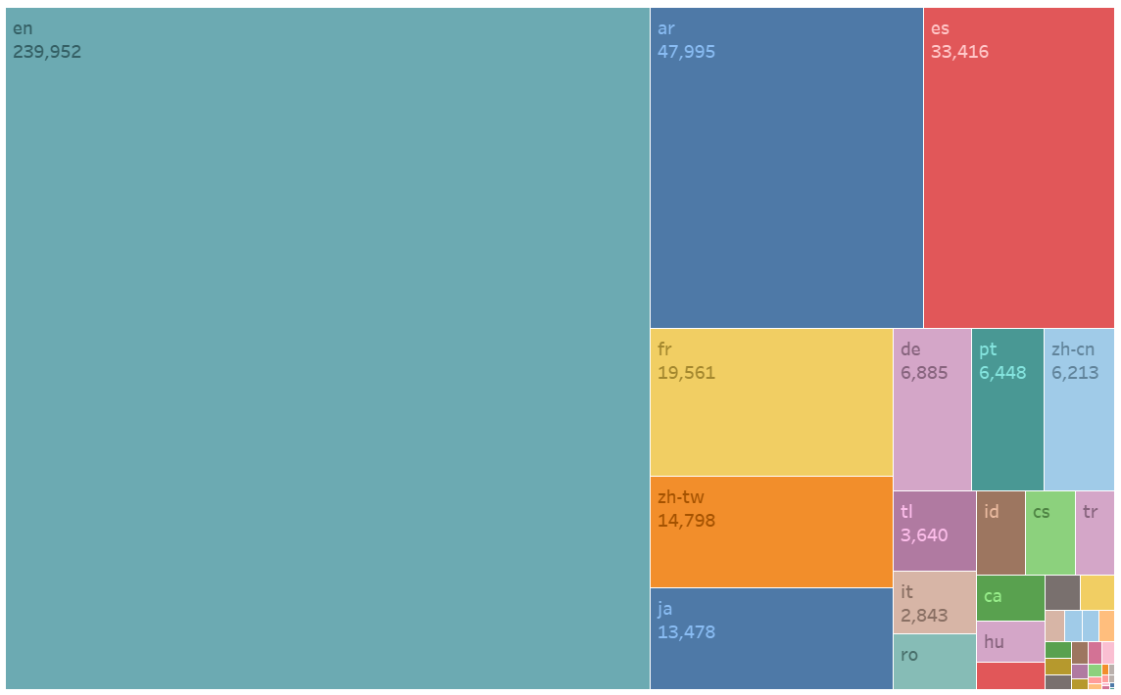Fig.18 Shows breakdown of the languages within the collected data. (October 14, 2019 to December 8, 2020)

English language messages have seen the largest increase over the duration of this project’s scope. Strikingly, they were sent in only slightly greater volume than the other languages at the end of 2019, but then increased in volume to a much greater degree than Arabic, Spanish or 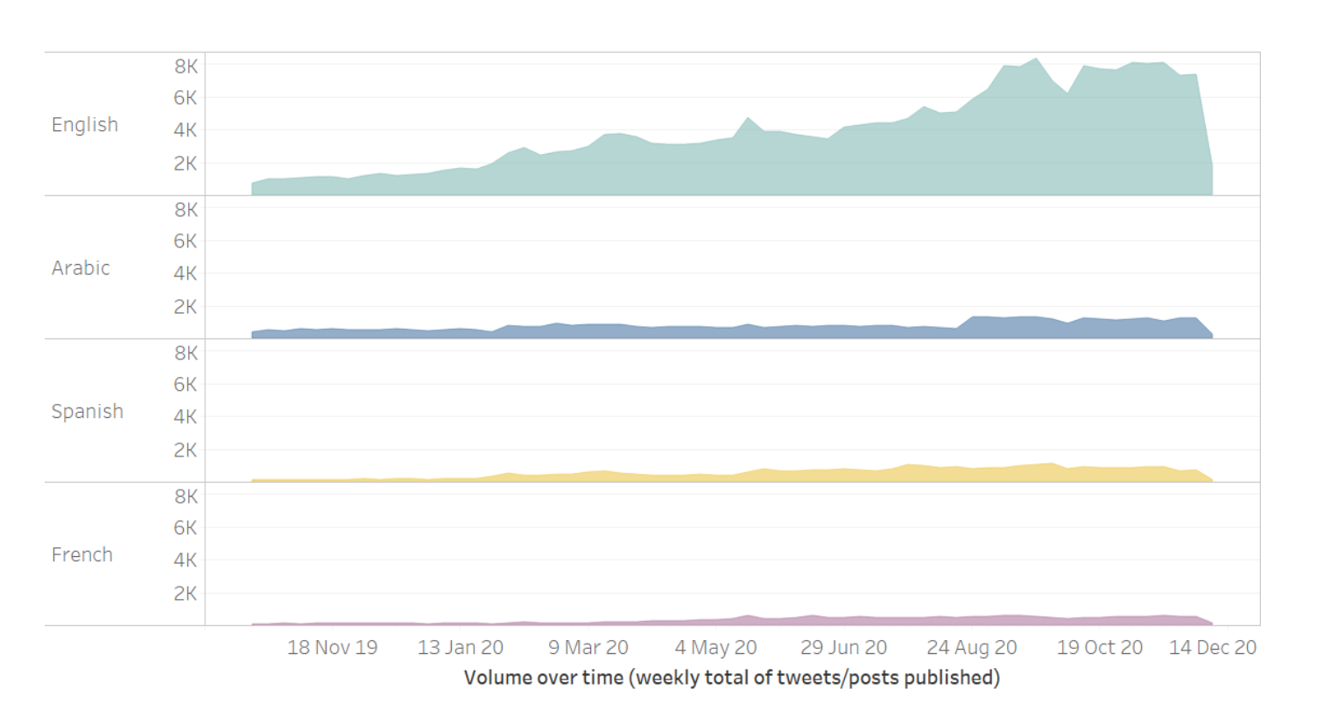French (see Fig.19).

Fig.19. Shows the increase in the total number of messages based on languages of intrest. (October 14, 2019 to December 8, 2020)

Across English, Spanish, Arabic and French, eight key themes were identified. Overall, 70% of the messages (401361 messages) collected for this project fell into at least one of the following:

* Chinese culture and people
* COVID-19
* Economy
* Geopolitics
* Military and security
* Politics and Society
* Technology
* Environment

118524 messages (20%) were categorised into more than one theme. The remainder 168120 messages (29%) remained uncategorised.

Chinese diplomatic accounts sent messages about geopolitics more than any other theme, followed by ‘politics and society’, COVID-19 and the economy. The environment and technology were raised comparatively rarely (see Fig.20). Please see the discussion section of the report, below, for the important caveats and considerations regarding how these themes 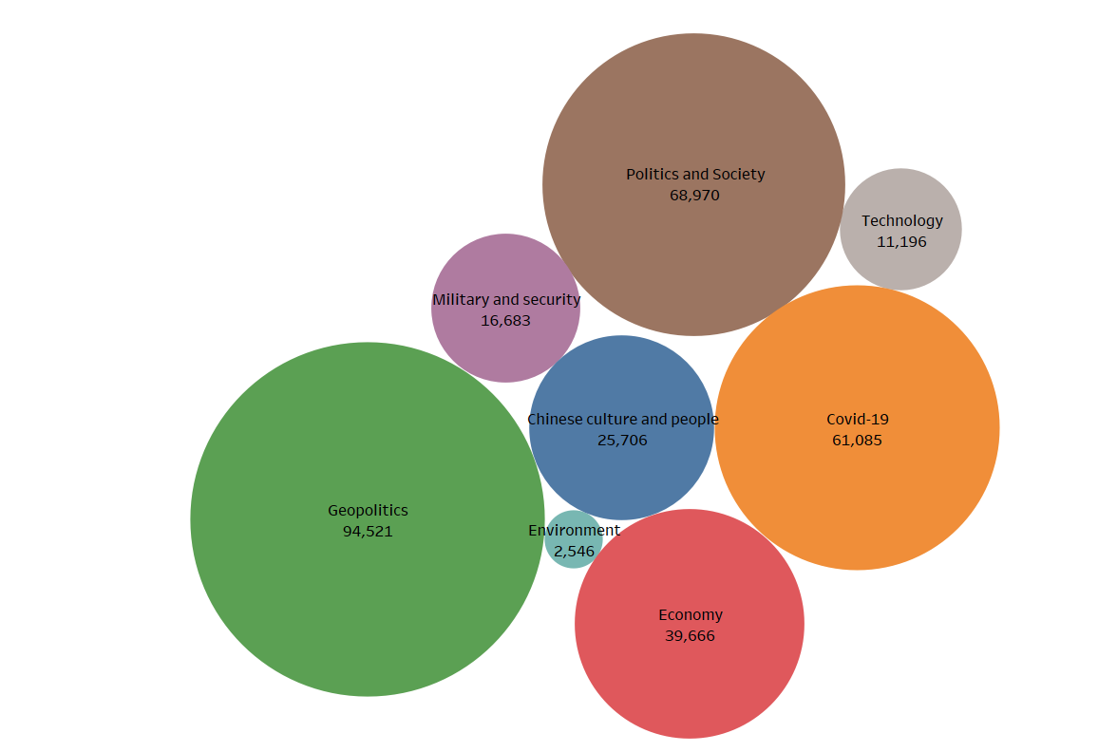were identified.

Fig.20. Shows the number of messages categorized in each theme. (October 14, 2019 to December 8, 2020)

Overall, geopolitics generally remained the most prolific theme throughout most of the time window studied by this project. From around February 2020, however, COVID-19 increased sharply in volume, before gradually reducing from approximately April onwards throughout the 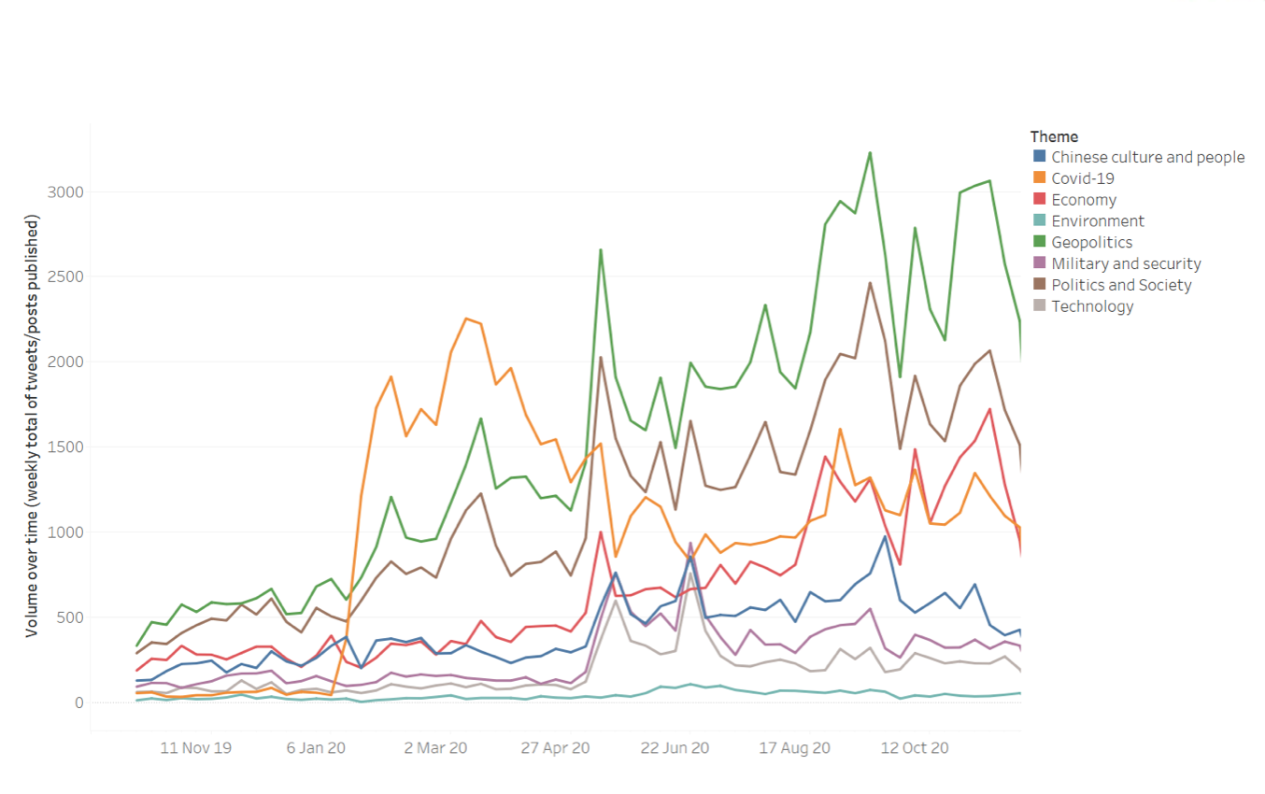rest of the year (see Fig.21).

Fig.21. Shows the total number of messages for each theme over time. (October 14, 2019 to December 8, 2020)

This same essential shape, of a general preponderance of geopolitics across late 2019 and 2020 but of a sharp increase in COVID-19 around March with a subsequent decline thereafter, was apparent across the different regions where China’s public diplomatic actors were based. This 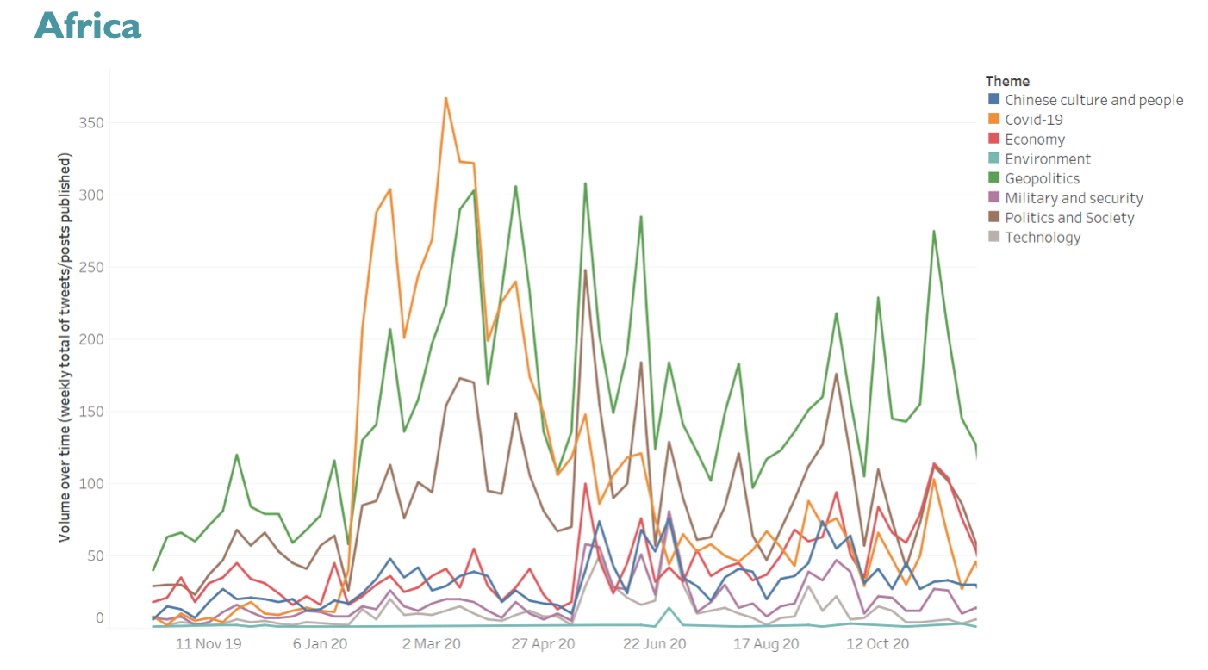was the case in Europe (see Fig.25):

Fig.22. Shows the total number of messages per theme over time (Africa region). (October 14, 2019 to December 8, 2020)

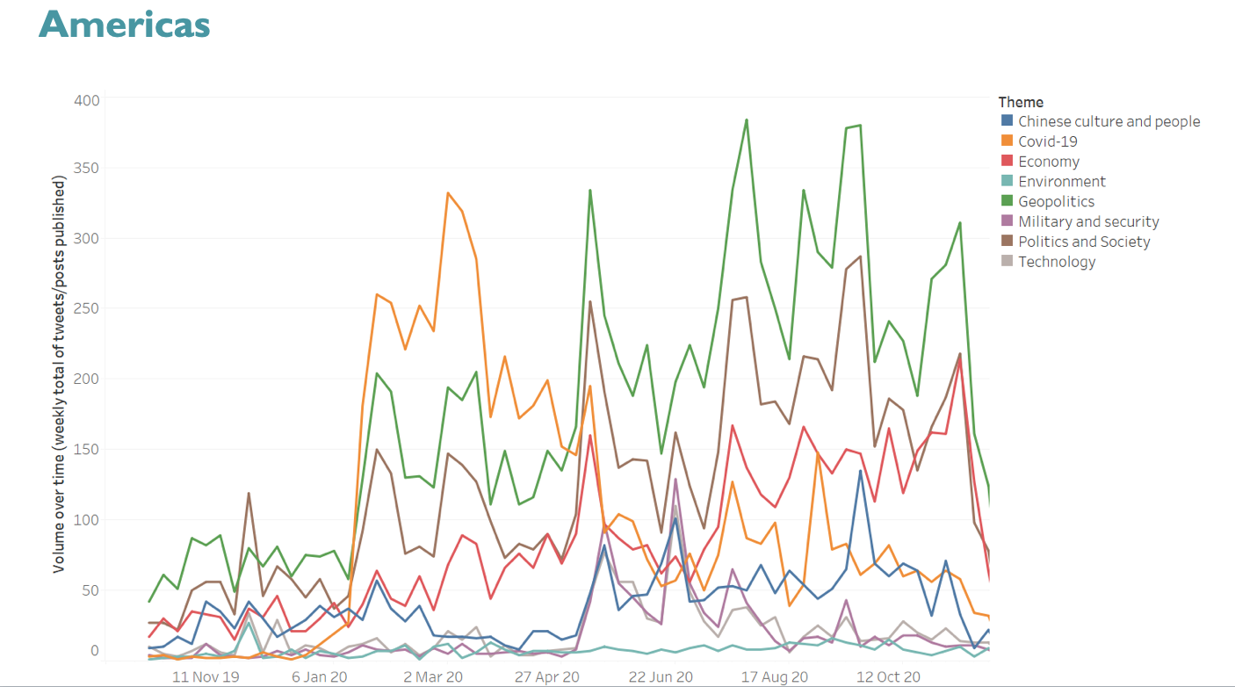Fig.23. Shows the total number of messages per theme over time (Americas region). (October 14, 2019 to December 8, 2020)

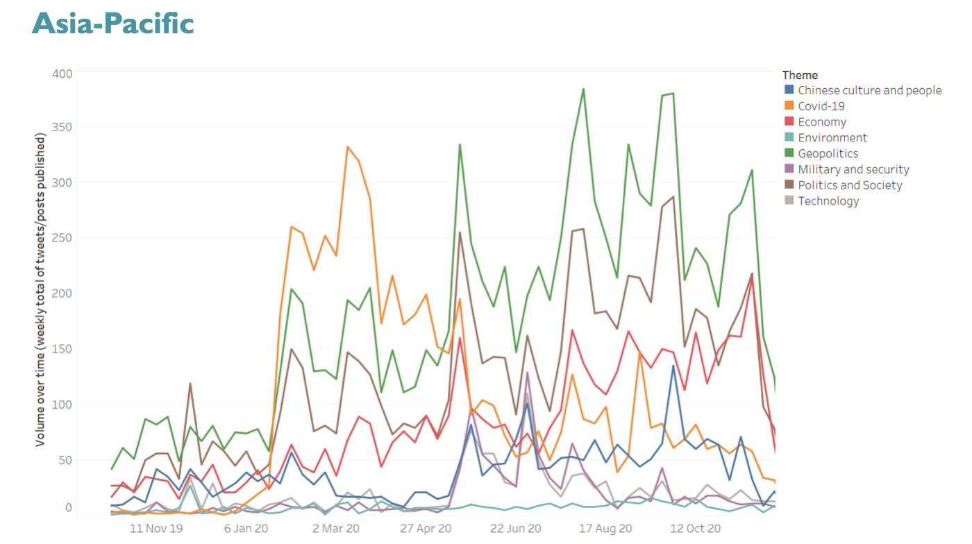

Fig.24. Shows the total number of messages per theme over time (Asia Pacific region). ). (October 14, 2019 to December 8, 2020)

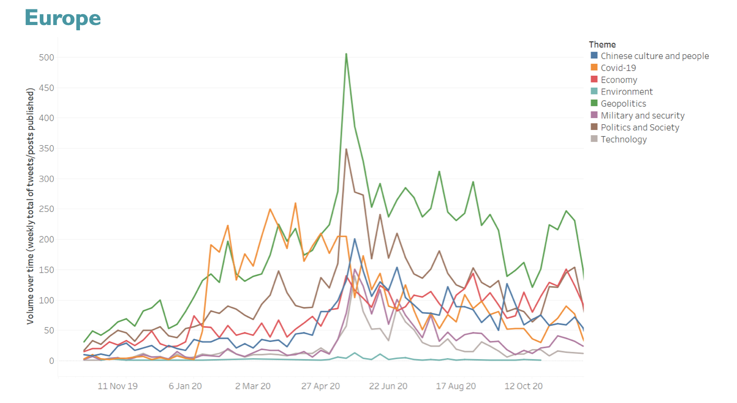Fig.25. Shows the total number of messages per theme over time (Europe region). (October 14, 2019 to December 8, 2020)

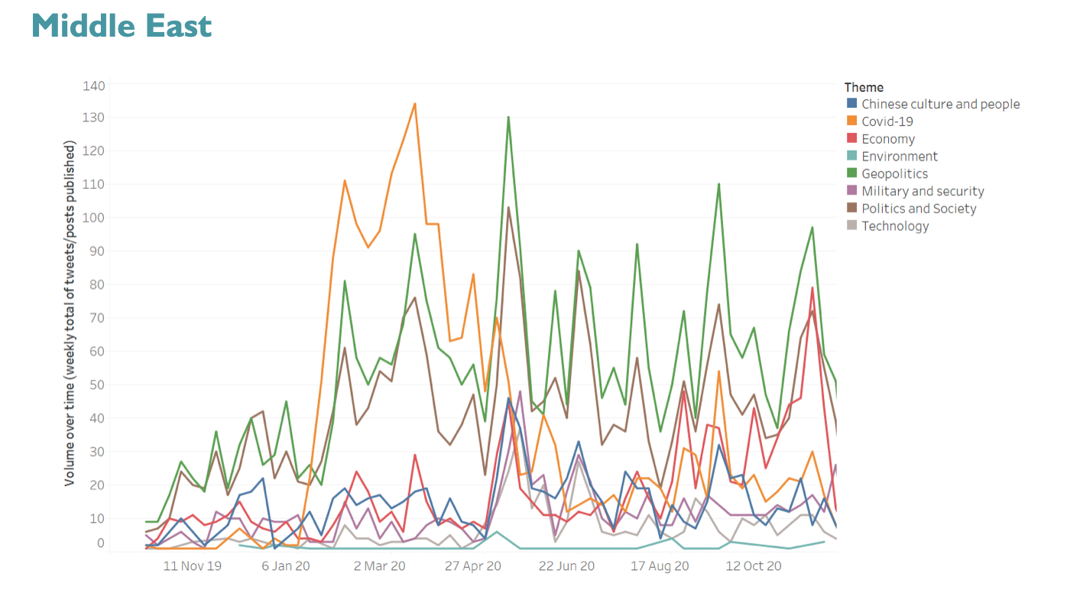

Fig.26. Shows the total number of messages per theme over time (Middle East region). (October 14, 2019 to December 8, 2020)

A very similar shape, albeit with smaller overall volumes, was also apparent from accounts based in the Middle East (see Fig.26).

This was not the case, however, for language, and this introduces the observation that there is a distinction and complexity between the language that China’s public diplomatic activity is in, and the regions that its messengers are based in.

In Arabic, for instance, ‘politics and society’ was the most prevalent theme. COVID-19 was much more prevalent in English than in French messages, and the economy was much more likely to be raised in Spanish than any other language. Alongside these differences, however, some important consistencies existed across all the languages studied: geo-politics remained very important, and there was very little discussion of technology, the environment

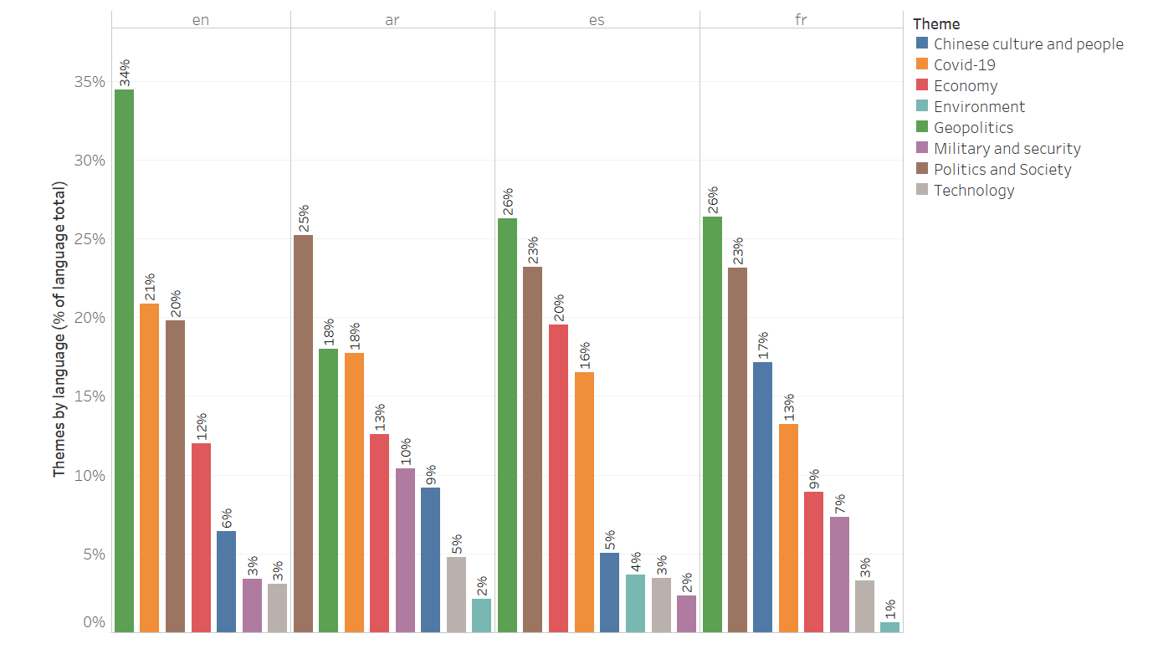

Fig.27. Themes breakdown by language. (October 14, 2019 to December 8, 2020)

We did not observe significant variation in the overall thematic emphasis of the different account types included in the study. Geopolitics remained the most prevalent theme across all account types, with ‘politics and society’ and COVID-19 consistently important too. Confucius Institutes were much more likely to discuss ‘chinese culture and people’ than any other account type (see Fig.28).

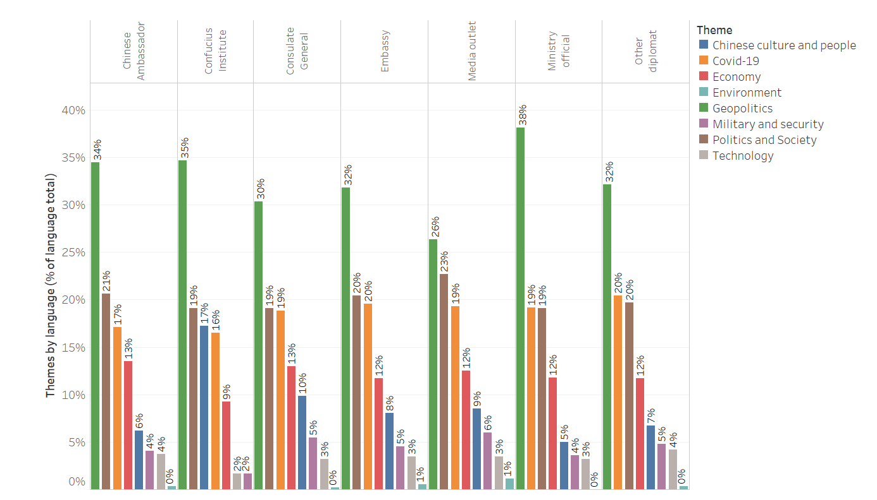

Fig.28. Themes breakdown by language and account category. (October 14, 2019 to December 8, 2020)

Part 3. Discussion and Caveats

Part 3 of this report contains observations and discussion regarding the data collected for this report and the methodology that was employed to collect and analyse this data.

**The amount of data available was reasonably high.** Although the number of accounts included in this study is reasonably small, given their nature the accounts themselves are very active. They tend to send a large number of messages, creating a reasonably large total of messages over the period of study. In addition, a large number (95%) of these accounts were collectible from Twitter and Facebook.

**Most messages related to one of the relevant themes of interest**.

However, …

**The analysis is likely missing other platforms.** Facebook and Twitter are not necessarily the only online platforms where China maintains a public diplomatic presence. Certainly, given the regional focus of much of the messaging, it is possible that a number of other, smaller and more regionally specific online venues are also used to reach different audiences, and these, of course, were not collective for this study.

**The keyword annotators likely introduce noise into the findings.** The manual selection of thematically relevant keywords was chosen as the approach for this project largely in the interests of time and straightforwardness. Given the need to make thematic classifications across a number of different languages, it was recognised that a number of different language teams would be needed without particular experience in social media research. However, this method has implications for the outputs that the project made in two important senses:

* + - The average precision of the keyword annotators was 0.57 f1_score.This means that for every 10 messages the classifiers placed into each theme, 4 will not be from that theme. This represents the fact that words can have a number of different meanings in different contexts.
    - The average recall of the keyword annotators was 0.50. This means that for every 10 messages actually on any given theme, the classifiers on average only successfully found 5 of them. Language is complex and manually curated keyword lists struggle to capture the often large number of different words that can be used to discuss any given theme.

Overall, the precision of the keyword annotators tended to be higher than the recall. This suggests that it is likely the keyword annotators are under-estimating the number of messages sent by China’s public diplomats that fall within each theme.

**Different language teams possibly developed different working understandings of how key words were chosen.** This may have led to differences in how expansive the keyword lists were, meaning that some annotators may have tended to identify more messages than others. This should be borne in mind especially with regard to comparisons made of thematic emphasis across languages.

**The performance of the keyword annotators would like be improved through the use of natural language processing**.There are a number of other approaches that can be used to categorise social media messages at scale. Best practice methodologies typically employ natural language processing technology to train machine learning algorithms to place each message into a different category. This approach is able to build linguistic models to understand the correlation of different words to different languages, and is capable of performing at higher levels of precision and recall than the keyword annotators used in this report.

**Overarching themes actually combine a number of really quite different topics.** It was necessary to select themes that encompassed most of the data that had been selected. This meant that the categories themselves combined a number of sometimes quite disparate sub-themes. The ‘economy’ theme, for instance, combined everything from poverty alleviation to marketing strategies. ‘Politics and society’ were perhaps the broadest theme, combining anything to do with the Chinese leadership to migration, human rights to policy initiatives. The annex of this report details the sub-themes that were contained within each of these over-arching themes.

**The data analysis will only be as comprehensive as the Master List that informs it.** Changes in diplomatic appointments and postings that are not expressed in the Master List will not be expressed in the final report. This may introduce inaccuracies into the results presented here.

**The longer term windows portrayed in the report are likely subject to a number of biases:**

* + - The account list of China’s diplomatic presences will be skewed towards accounts that were active when the list was made, and will possibly systematically underestimate the number of accounts active in the past.

* + - Data collection issues from Twitter API:
      * API limitations
        + Twitter API collects 3000 tweets from the past.
        + Accounts that post a lot may not go back in time very far: if we collect the user’s past 3000 messages, then for some users we go back 1 day (if they posted 3000 a day), and for others we go back years (if they posted a few messages a day)
        + The main limitations would be in the timeframe before we started the collection.

Part 4. Annex

**Thematic Framework**

**Chinese Online Diplomacy - Themes**

**Economy**

* + Chinese economic development
  + Poverty alleviation
  + Economic reform
  + Initiatives
  + Belt and Road initiative (BRI)
  + Trade
  + Transport infrastructure
  + Energy
  + Mining
  + Agriculture
  + Finance
  + Taxation
  + Industry
  + Business
  + Marketing strategies
  + Advertising
  + E-Commerce
  + Chinese multinationals

**Politics and Society**

* + Chinese leadership appearances and messaging
  + Xi Jinping
  + Chinese political system
    - Grand national unity
    - Three represents
    - Xi Jinping thought
  + Policy initiatives
  + Corruption
  + Crime
  + Rule of Law
  + Migration
  + Welfare
  + Democracy
  + Protest
  + Human Rights
    - Three evil forces
    - Freedom of speech
    - Religious freedom
    - Media freedom
    - treatment of ethnic/religious/other groups
      * Xinjiang, Uighurs
    - LGBTQ+ rights
  + Gender
  + Health

**Covid-19**

* + - Measures
    - Vaccine
    - Covid diplomacy
    - Outbreak origin

**Technology**

* + Artificial Intelligence
  + Cybersecurity
  + Technology infrastructure
  + Internet
  + Huawei,5G, 6G
  + Space exploration/tech/progress/satellites

**Environment**

* + Environmental protection/conservation
  + Reduction of greenhouse gases
  + Sustainable technologies
  + Green energy/Solar power/wind power
  + Wildlife

**Military and Security**

* + Modernisation of China’s armed forces
    - Hypersonic missiles
    - Nuclear weapons
    - Robots/drones
    - Cyber warfare
  + Chinese peacekeeping forces
  + Navy
    - Visits
  + Exercises/Parades
  + Policing
  + National Security
  + Intelligence services
  + Counterterrorism
  + Cooperation/training
  + South China Sea
  + Denuclearisation/non-proliferation

**Geopolitics**

* + China and the World
    - China and the UK
    - China and the EU
    - China and the US
    - China and its neighbours
    - China and India
    - China and Russia
    - China and N Korea
    - US boycotts/sanctions - Iran, Venezuela, Cuba, etc
    - China and Taiwan
    - China and MENA
    - Historical injustices towards China, e.g., Japan, Britain, US (Korean War, etc)
    - Hong Kong
    - Macau
  + Diaspora
  + Multilateralism/China and UN
  + Anti-imperialism
  + Non-interference
  + Foreign interference
  + Territorial disputes
  + Responsible power
  + Cooperation
    - Technical cooperation and training
  + Diplomacy
    - Development diplomacy
    - Vaccine diplomacy
    - Disaster recovery
    - Aid
    - Cultural diplomacy
    - Diplomatic appointments, engagements
    - Community engagement
  + Election commentary
    - US election

**Chinese culture and people**

* + Chinese history
  + Ethnic minorities
  + Religions
  + Food diplomacy
  + Tourism/Travel
  + Chinese festivals
  + Sport
    - Olympics
  + Education
    - Confucius Institutes
    - Foreign students in China
    - Universities
  + Chinese diaspora outreach